Problem 3 – Todo List
Problem for exam preparation for the "JS Front-End" course @ SoftUni .
Submit your solutions in the SoftUni judge system at https://judge.softuni.org/Contests/3878/Exam-Preparation-I.

Working with Remote Data
For the solution of some of the following tasks, you will need to use an up-to-date version of the local REST service, provided in the lesson’s resources archive. You can read the documentation here.
Environment Specifics
Please be aware that every JS environment may behave differently when executing code. Certain things that work in the browser are not supported in Node.js, which is the environment used by Judge.
The following actions are NOT supported:
- .forEach() with NodeList (returned by querySelector() and querySelectorAll())
- .forEach() with HTMLCollection (returned by getElementsByClassName() and element.children)
- Using the spread-operator (...) to convert a NodeList into an array
- append() in Judge (use only appendChild())
- prepend()
- replaceWith()
- replaceAll()
- closest()
- replaceChildren()
- Always turn the collection into a JS array (forEach, forOf, et.)
If you want to perform these operations, you may use Array.from() to first convert the collection into an array.

Requirements
Write a JS program that can load, create, remove and edit a list of tasks. You will be given an HTML template to which you must bind the needed functionality.
First you need to install all dependencies using the “npm install” command
Then you can start the front-end application with the “npm start” command
You also must also start the server.js file in the server folder using the “node server.js” command in another console (BOTH THE CLIENT AND THE SERVER MUST RUN AT THE SAME TIME)
At any point, you can open up another console and run “npm test” to test the current state of your application, it’s preferable for all of your test to pass locally before you submit to the judge platform, like this:
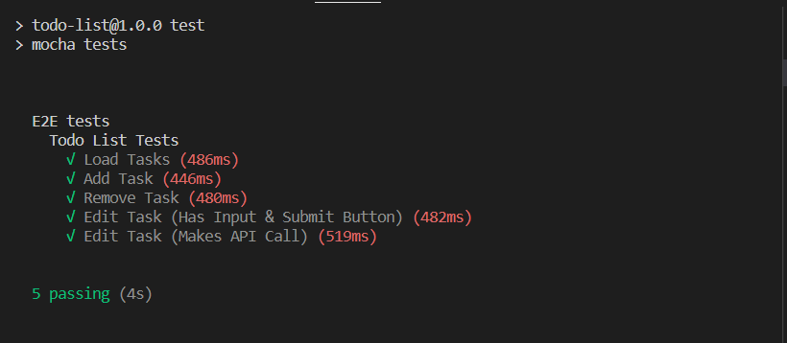

Endpoints
- http://localhost:3030/jsonstore/tasks/
- http://localhost:3030/jsonstore/tasks/:id

Load Tasks
Clicking the [Load All] button should send a GET request to the server to fetch all tasks in your local database.
Each task is a list item in the following format:
<li>
<span>Go Shopping</span>
<button>Remove</button>
<button>Edit</button>
</li>
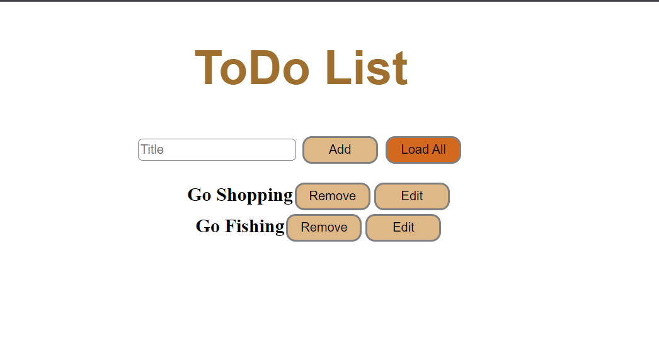

Add Task
Clicking the [Add] button should send a POST request to server, creating a new task with the name from the input value and after the successful creation you should send another GET request to fetch all tasks, including the newly added one.
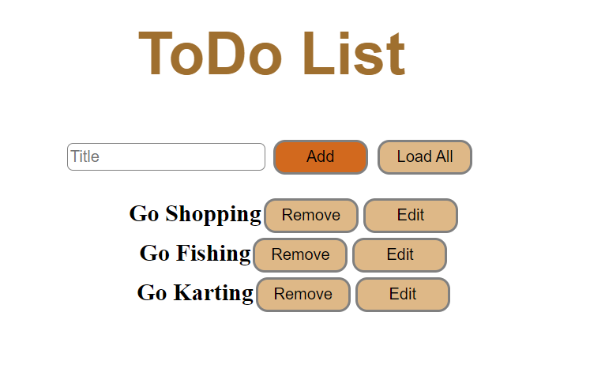

Remove Task
Clicking the [Remove] button should send a DELETE request to the server and remove the item from your local database. After you’ve removed it successfully, fetch the items again.
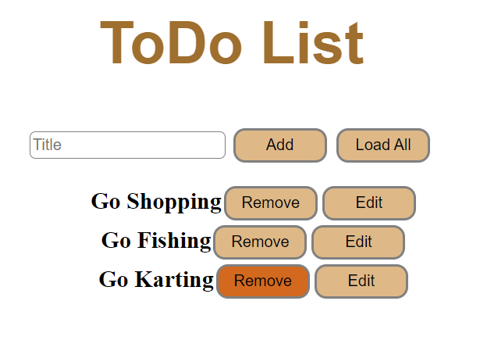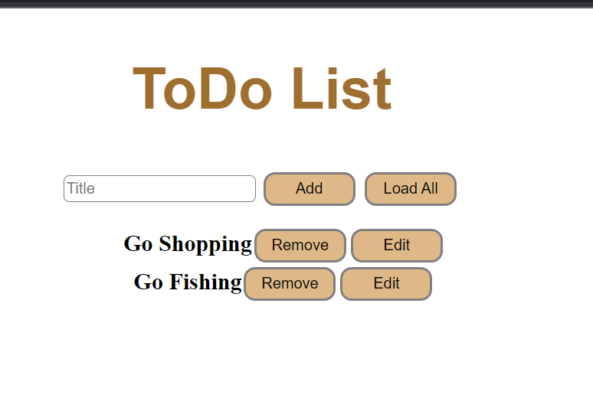

Edit Task
Clicking the [Edit] button should change the DOM Structure for that list element, instead of a span you should create an input field with the current name as value and exchange the Edit button with a Submit button.
After clicking the [Submit] button you should send a PATCH request to the server to modify the name of the changed item, after the successful request you should fetch the items again and see that changes have been made.
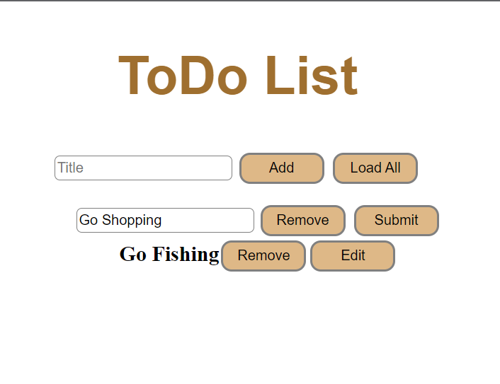
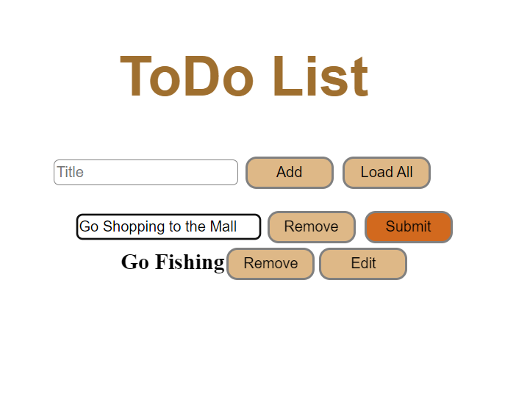
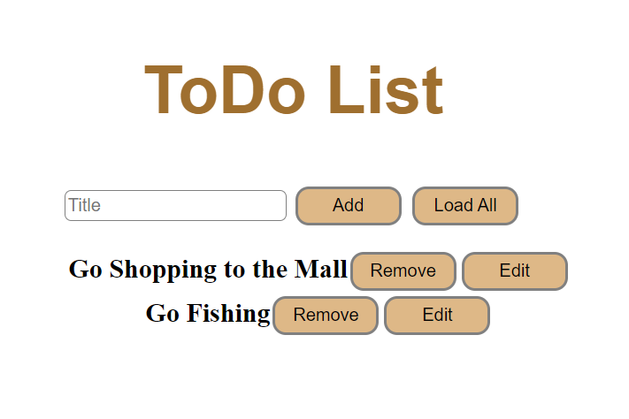

Submitting Your Solution
Place in a ZIP file the content of the given resources including your solution. Exclude the node_modules & tests folders. Upload the archive to Judge.
